Database Management System – cs422 DE
Lab 2 – Week 5
-----------------------------------------------------------------------------------------------------------------
This Lab is based on lecture 5 (chapters 14).
- Submit your own work on time. No credit will be given if the lab is submitted after the due date.
- Note that the completed lab should be submitted in .doc, .docx, .rtf or .pdf format only.
- If you think that your answer needs more explanation to get credit then please write it down.
---------------------------------------------------------------------------------------------------------------

Consider a relation with following attributes:

EmpNo : Employee Number
EmpName : Employee Name
EmpEmail : Employee Email
ProjNo : Project Number
ProjName : Project Name
EmpGrade : Employee Grade
HrlyRate : Hourly rate of compensation
Employees of the same grade receive the same hourly compensation
HrsWorked : Hours a particular employee worked on a particular project

- Create this table and sample data in SQL Server. There must be at least 10 rows. There must be 3 to 6 Employees and 3 to 6 projects. You need to add the screenshot of the table showing all the rows.
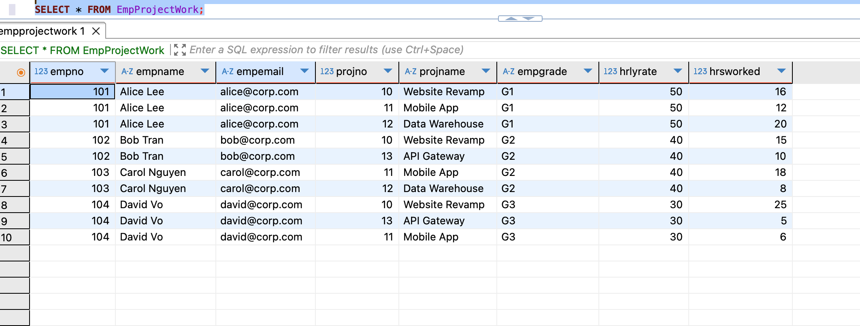
- Find all functional dependencies.
ANS: EmpNo -> EmpName, EmpEmail, EmpGrade; EmpGrade -> HrlyRate; ProjNo -> ProjName; (EmpNo, ProjNo) -> HrsWorked.

- Find all Candidate Keys.
ANS: (EmpNo, ProjNo)

- Find a Primary Key.
ANS: (EmpNo, ProjNo)

- Find all partial dependencies.
ANS: EmpNo -> EmpName, EmpEmail, EmpGrade; ProjNo -> ProjName.

- Normalize to 2NF.
ANS:
Decompose the original relation (EmpNo, EmpName, EmpEmail, EmpGrade, HrlyRate, ProjNo, ProjName, HrsWorked) into:

EMPLOYEE(EmpNo, EmpName, EmpEmail, EmpGrade, HrlyRate) – PK: EmpNo
PROJECT(ProjNo, ProjName) – PK: ProjNo
EMP_PROJECT(EmpNo, ProjNo, HrsWorked) – PK: (EmpNo, ProjNo), FKs: EmpNo -> EMPLOYEE, ProjNo -> PROJECT

All non-key attributes in each table now depend on the whole key of that table (no partial dependencies).

- Show new tables after 2NF (based on the sample data you created in 1 above). Screenshots of all the tables are required.
ANS:
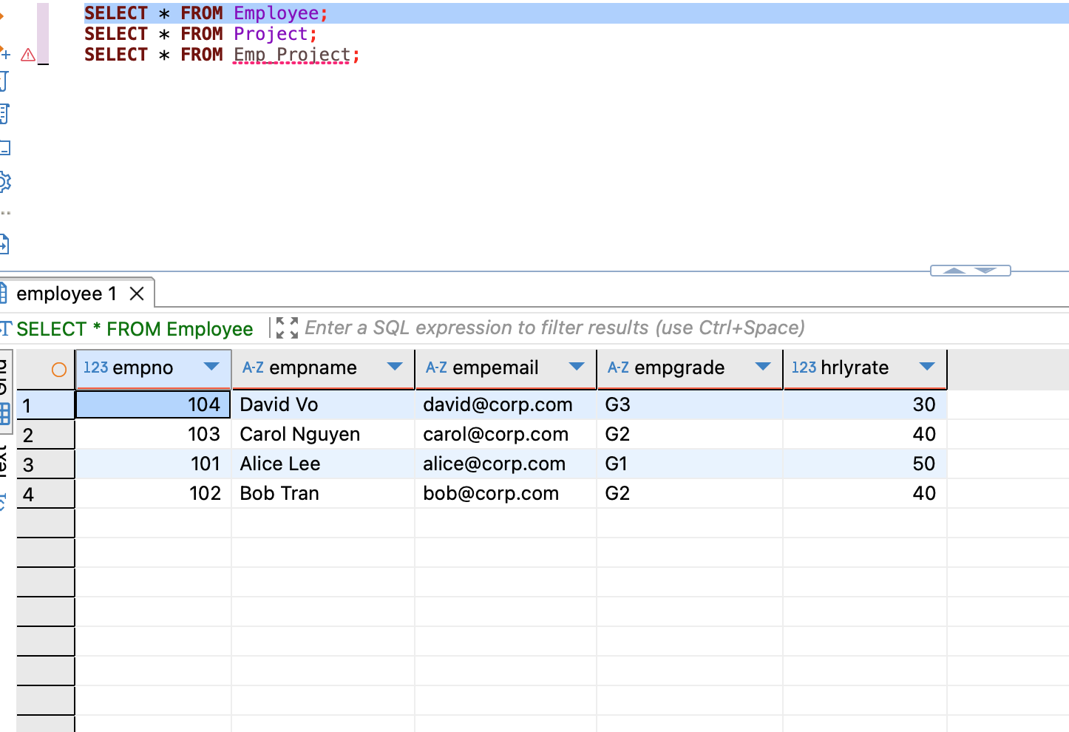

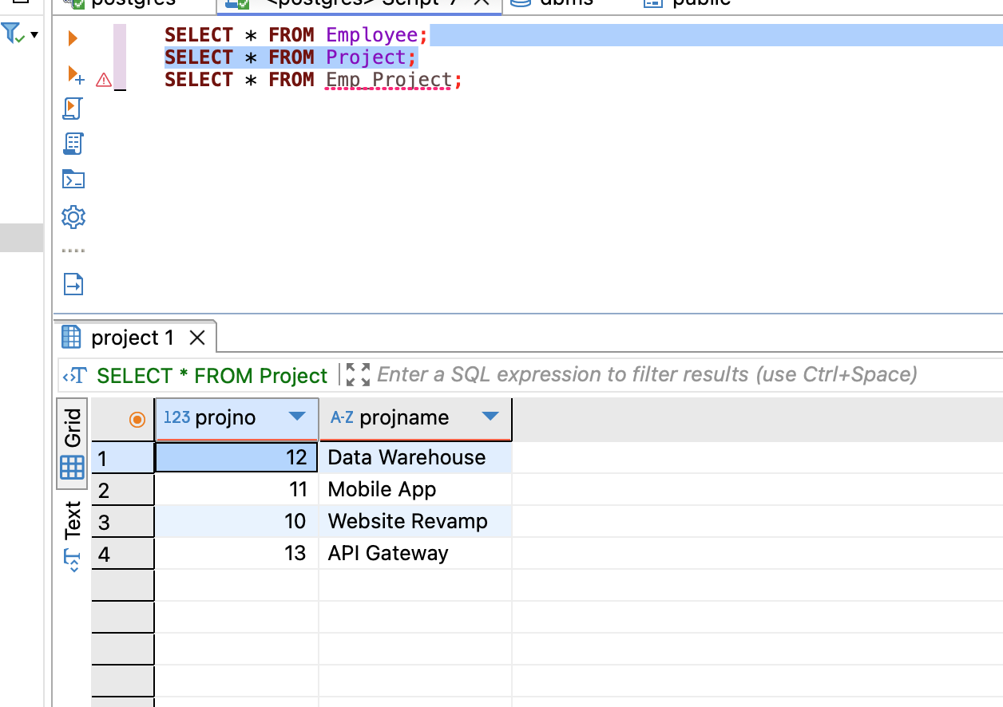
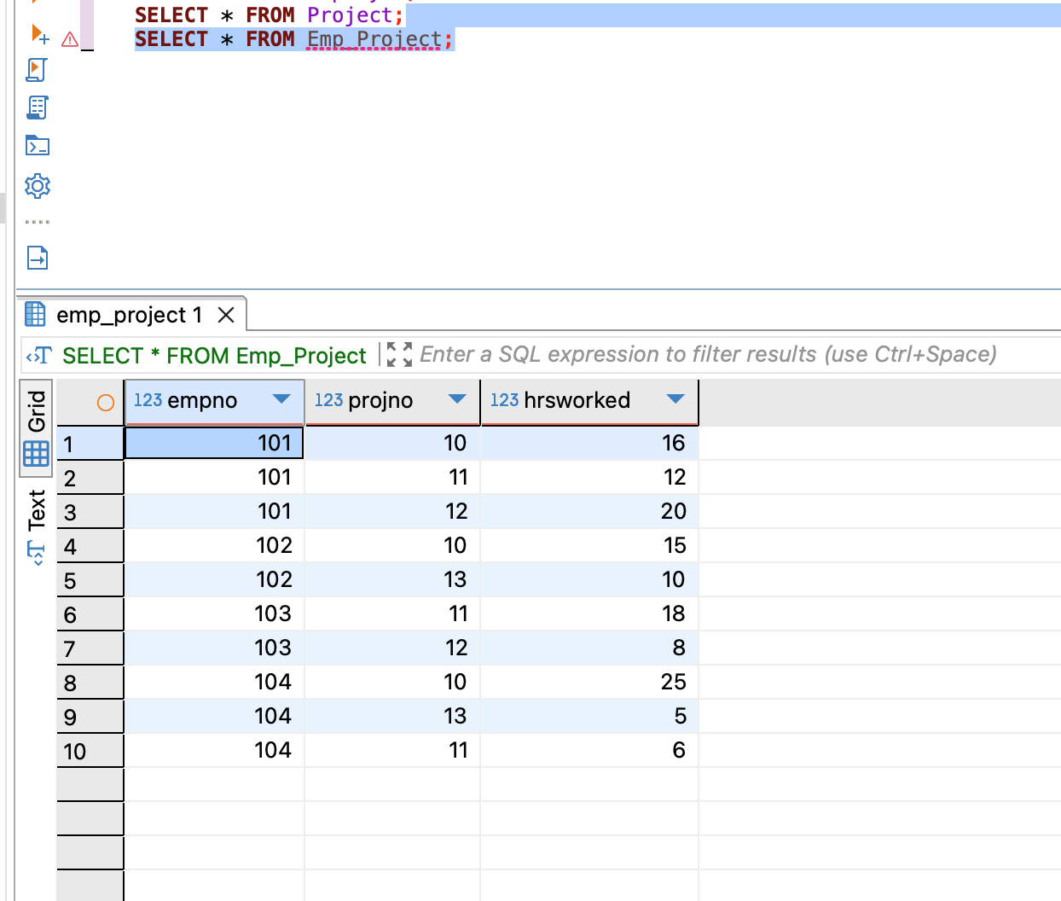

- Normalize to 3NF.
ANS:

Remove the transitive dependency EmpNo -> EmpGrade -> HrlyRate by separating grade and rate:
EMPLOYEE(EmpNo, EmpName, EmpEmail, EmpGrade) – PK: EmpNo, FK EmpGrade -> GRADE
GRADE(EmpGrade, HrlyRate) – PK: EmpGrade
PROJECT(ProjNo, ProjName) – PK: ProjNo
EMP_PROJECT(EmpNo, ProjNo, HrsWorked) – PK: (EmpNo, ProjNo), FKs: EmpNo -> EMPLOYEE, ProjNo -> PROJECT
Each non-key attribute now depends only on the key, the whole key, and nothing but the key (3NF).

- Show new tables after 3NF (based on the sample data you created in 1 above). Screenshots of all the tables are required.
